## AN INTERNSHIP REPORT ON

**RESEARCH AND DEVELOPMENT ON ENTERPRISE RESOURCE**

**PLANNING, CHENNAI**

***Submitted by***

# RAMANATHAN S P (113221031119)

***In partial fulfillment for the award of the degree Of***

# BACHELOR OF ENGINEERING

**IN**

**COMPUTER SCIENCE AND ENGINEERING**



# VELAMMAL ENGINEERING COLLEGE, CHENNAI-66.

(An Autonomous Institution, Affiliated to Anna University, Chennai)

# 2023-2024

**VELAMMAL ENGINEERING COLLEGE, CHENNAI-66**



# BONAFIDE CERTIFICATE

Certified that this internship report **“RESEARCH AND DEVELOPMENT ON ENTERPRISE RESOURCE PLANNING, CHENNAI”** is the

bonafide work of **RAMANATHAN S P** (113221031119), carried out at **AARA INFOTECH ADYAR CHENNAI** during 27.11.2023 to 10.01.2024.

## Dr. B. MURUGESHWARI Mrs. K. MOHANAMBAL

PROFESSOR & HEAD ASSISTANT PROFESSOR - II

Dept. of Computer Science Engineering Dept. of Computer Science Engineering Velammal Engineering College Velammal Engineering College

Chennai – 600 066 Chennai – 600 066

**CERTIFICATE FROM INDUSTRY**

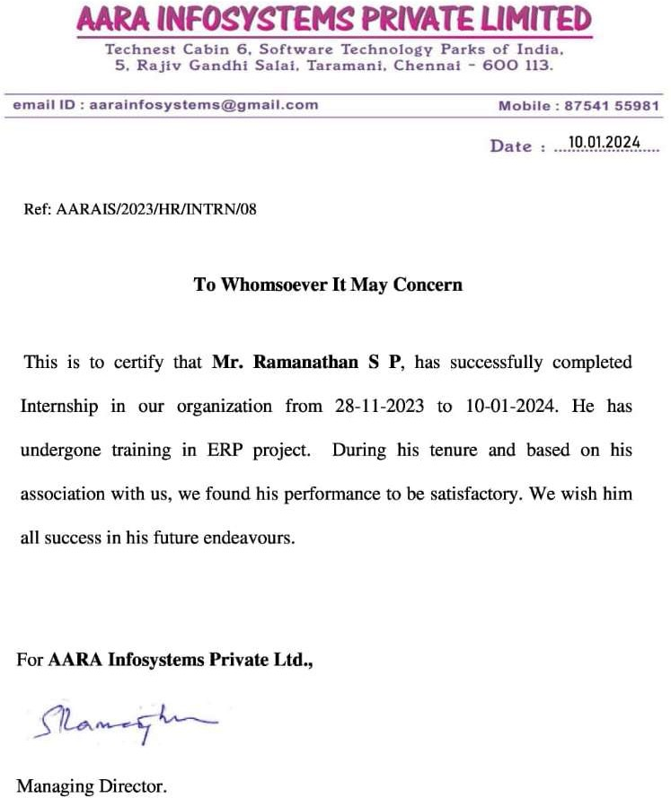

# CERTIFICATE OF EVALUATION

COLLEGE NAME : VELAMMAL ENGINEERING COLLEGE BRANCH : COMPUTER SCIENCE AND ENGINEERING

SEMESTER : VI

|  |  |  |  |
| --- | --- | --- | --- |
| **Sl. No** | **Name of the student who has done the Internship** | **Title of the Internship** | **Name of faculty coordinator with designation** |
| 1 | RAMANATHAN S P | Research and Development on Enterprise Resource Planning, Chennai. | Mrs. K. Mohanambal  Assistant Professor- II |

This report of internship work submitted by the above student in partial fulfillment for the award of Bachelor of Computer Science and Engineering Degree in Anna University was evaluated and confirmed to be reports of the workdone by the above student and then assessed.

Submitted for Internal Evaluation held on ..............

## Examiner 1 Examiner 2 Examiner 3

**TABLE OF CONTENTS**

|  |  |  |
| --- | --- | --- |
| **CHAPTER NO.** | **TITLE** | **PAGE NO.** |
|  | **ACKNOWLEDGMENT** | **vii** |
|  | **ABSTRACT** | **viii** |
|  | **LIST OF FIGURES** | **ix** |
|  | **LIST OF ABBREVIATIONS** | **x** |
| **1.** | **INTRODUCTION TO COMPANY’S PROFILE** |  |
|  | 1.1 INTRODUCTION | 1 |
|  | 1.2 COMPANY’S PROFILE | 2 |
| **2.** | **PROBLEM STATEMENT AND PROPOSED SOLUTION** |  |
|  | 2.1 PROBLEM STATEMENT | 3 |
|  | 2.2 PROPOSED SOLUTION | 4 |
| **3.** | **LITERATURE REVIEW** |  |
|  | 3.1 IMPLEMENTATION CHALLENGES | 7 |
|  | 3.2 SKILLS RELEVANT TO ERP | 7 |
|  | 3.3 ERP SYSTEM SOFTWARE | 8 |
| **4.** | **DESIGN IMPLEMENTATION** |  |
|  | 4.1 REQUIREMENT ANALYSIS | 10 |
|  | 4.2 SYSTEM ARCHITECTURE DESIGN | 10 |
|  | 4.3 USER INTERFACE DESIGN | 11 |

|  |  |  |
| --- | --- | --- |
|  | 4.4 MODULE CONFIGURATION | 11 |
|  | 4.5 INTEGRATION AND DATA MIGRATION | 11 |
|  | 4.6 CUSTOMIZATION AND EXTENSIONS | 12 |
| **5.** | **TESTING** |  |
|  | 5.1 UNIT TESTING | 13 |
|  | 5.2 INTEGRATION TESTING | 13 |
|  | 5.3 USER ACCEPTANCE TESTING | 14 |
|  | 5.4 PERFORMANCE TESTING | 14 |
|  | 5.5 SECURITY TESTING | 14 |
| **6.** | **RESULT** |  |
|  | 6.1 RESULT | 16 |
| **7.** | **CONCLUSION** |  |
|  | 7.1 CONCLUSION | 18 |
|  | **APPENDIX- 1** | 20 |
|  | **APPENDIX -2** | 22 |
|  | **REFERENCES** | 24 |

## ACKNOWLEDGMENT

I wish to acknowledge with thanks to the significant contribution given by the management of our college **Chairman, Dr. M. V. Muthuramalingam**, and our **Chief Executive Officer Thiru. M.V.M. Velmurugan**, for their extensive support.

I would like to thank **Dr. S. SATISH KUMAR, Principal** of Velammal Engineering College, for giving me this opportunity to do this project.

I wish to express my gratitude to our effective **Head of the Department, Dr. B. Murugeshwari**, for her moral support and for her valuable innovative suggestions, constructive interaction, constant encouragement and unending help that have enabled me to complete the project.

I wish to express my indebted humble thanks to the Company **Aara Infotech Adyar, Chennai** and the External Guide **Mr.Ilayaraja,** and **Mr. RamShanmugam, Managing Director** for their invaluable guidance in shaping of this project.

I wish to express my sincere gratitude to my **Internal Guide, Mrs. K. MOHANAMBAL, Assistant Professor - II**, Department of Computer Science and Engineering for her guidance, without whom this project would not have been possible.

I am grateful to the entire staff members of the department of Computer Science and Engineering for providing the necessary facilities to carry out the project. I would especially like to thank my parents for providing me with the unique opportunity to work, and for their encouragement and support at all levels.

Finally, my heartfelt thanks to **The Almighty** for guiding me throughout the life.

## ABSTRACT

This internship report explores the implementation of ERPNext software at **AARA INFOTECH** The report aims to provide insights into the company’s decision to adopt ERPNext, the process of implementation, and the outcomes achieved. The study begins with an overview of the company’s background and the challenges faced in its existing business processes. A literature review on ERP systems and ERPNext software sets the stage for understanding the benefits and challenges associated with implementing such systems. The methodology section outlines the approach used to study ERPNext modules and assess their suitability for the company’s needs.

The report Identifies specific problems within the company’s operations and proposes ERPNext as a comprehensive solution to address these challenges. It highlights key features and modules of ERPNext relevant to the company’s requirements, such as finance, inventory management, human resources, and customer relationship management. Drawing upon examples of successful ERPNext implementations in similar contexts, the report demonstrates the potential benefits and effectiveness of the software.

This report serves as a valuable resource for understanding the benefits and challenges of ERPNext implementation and offers insights into best practices for leveraging ERP systems to drive organizational growth and efficiency.

## LIST OF FIGURES

|  |  |  |
| --- | --- | --- |
| **Fig. No.** | **Figure Name** | **Page Number** |
| 1 | User Interface | 22 |
| 2 | Custom Doctype | 22 |
| 3 | Custom Doctype | 23 |
| 4 | Workflow Builder | 23 |

**LIST OF ABBREVIATIONS**

**ERP** Enterprise Resource Planning

**CRM** Customer Relationship Management

**BOM** Bill Of Materials

**API** Application Program Interface

**P&L** Profit & Loss

## CHAPTER 1 INTRODUCTION

During my internship at a software company engaged in providing IT services for various business and government projects, I was tasked with exploring and understanding ERPNext software. The company relies on numerous documents including supplier-client contracts, tender documents, and payment reports to effectively manage its operations. Recognizing the need for a centralized system to streamline document management and enhance operational efficiency, the company decided to implement ERPNext.

As a Computer Science and Engineering (CSE) student, my primary objective was to delve into the functionalities and features of ERPNext to comprehend its capabilities and potential applications within the organization. Throughout the internship, I focused on studying the workflows, configuring modules, and customizing document types (doctypes) to align with the specific requirements of the company’s users.

This report aims to provide insights into the exploration and utilization of ERPNext software during my internship, highlighting its significance in addressing the company’s document management needs and fostering a more organized and streamlined workflow environment. Through this endeavor, I gained practical experience in software exploration, configuration, and

customization, which significantly contributed to my professional development and understanding of enterprise resource planning systems.

## COMPANY’S PROFILE

Aara Tech is proud to boast a talented and enthusiastic team of professionals who are driven to be successful by ensuring their client’s succeed. With a finger on the pulse of evolving technologies and an unswerving commitment to our clients, Aara Tech brings to your business the necessary experience you can rely on for running your IT projects cost effectively, with our 3’O’ Right Sourcing model.

We work with our clients on an ongoing basis to develop strategies for future growth, and to continuously monitor and evaluate their sites as they grow.

This study and utilisation of ERPNext Software, Chennai was carried out at **AARA INFOTECH, ADYAR, CHENNAI** under the guidance of Mr. RamShanmugam, Managing Director, along with Mr.Ilayaraja, Project Head.

## CHAPTER 2 PROBLEM STATEMENT

Prior to the implementation of ERPNext software, the software company faced significant challenges in managing its diverse array of documents essential for project execution and organizational operations. These challenges stemmed from the absence of a unified system for document management, resulting in inefficiencies, data redundancies, and a lack of transparency in processes.

## Key challenges include:

Fragmented Document Management: Documents related to supplier-client contracts, tender submissions, and payment reports were scattered across various platforms, making it challenging to locate and track essential information.

Inefficient Workflow Processes: The absence of standardized workflows resulted in disjointed processes, leading to delays, errors, and miscommunications among stakeholders involved in project management and execution.

Data Redundancy and Inaccuracy: Without a centralized system, data redundancy and inaccuracies were common, leading to discrepancies in project documentation, procurement, and financial reporting.

Lack of Real-Time Visibility: Decision-making processes were hindered by the absence of real-time visibility into project statuses, resource utilization, and

financial metrics, impeding the company’s ability to respond swiftly to evolving project requirements and challenges.

## PROPOSED SOLUTION

To address the document management challenges and operational inefficiencies identified during the internship, the proposed solution entails the implementation of ERPNext software as a comprehensive Enterprise Resource Planning (ERP) system. ERPNext offers a robust suite of features and functionalities designed to streamline business processes, enhance collaboration, and provide real-time insights into organizational operations. The proposed solution encompasses the following key components:

## Centralized Document Repository:

ERPNext provides a centralized repository for storing and managing documents related to supplier-client contracts, tender submissions, payment reports, and other project-related documentation. With a unified document management system, users can easily access, update, and track essential information, eliminating the need for disparate document repositories and manual tracking methods.

## Standardized Workflows:

ERPNext enables the creation and customization of standardized workflows tailored to the company’s specific requirements and processes. By defining clear workflows for document approval, project management, procurement, and financial transactions, the software facilitates seamless collaboration and ensures adherence to established protocols and timelines.

## Automated Processes:

Leveraging automation capabilities, ERPNext automates routine tasks and processes, reducing manual intervention and minimizing the risk of errors and delays. Automated alerts and notifications keep stakeholders informed about pending tasks, deadlines, and critical milestones, fostering a proactive and efficient working environment.

## Real-Time Reporting and Analytics:

ERPNext offers comprehensive reporting and analytics functionalities, allowing users to generate real-time reports and dashboards on project performance, financial metrics, resource utilization, and other key performance indicators. By gaining actionable insights into operational trends and patterns, decision-makers can make informed decisions and proactively address emerging challenges and opportunities.

## Scalability and Customization:

As an open-source ERP solution, ERPNext offers scalability and flexibility to accommodate the company’s evolving business needs and growth trajectory. With customizable modules and workflows, the software can be tailored to support diverse project requirements and organizational structures, ensuring alignment with strategic objectives and operational priorities.

The proposed solution aims to empower the company with a robust and Integrated ERP platform that streamlines document management, enhances workflow efficiency, and enables data-driven decision-making. By embracing ERPNext software, the company can position itself for long-term success and competitiveness in today’s dynamic business landscape.

## CHAPTER 3 LITERATURE REVIEW

**1.Literature Review of ERP Systems Implementation Challenges: Author:** Aditya Patil and Shital Raut (2022)

This paper presents a comprehensive literature review of the challenges faced during and after the implementation of enterprise resource planning (ERP) systems. Through a thorough search across various databases, 20 articles were identified that address issues related to global demands, which often lead to conflicts between parent and subsidiary companies. Parent companies tend to favor standardized solutions for greater control, while local subsidiaries prioritize maintaining local processes and routines. The main objective of this paper is to shed light on these conflicting objectives and highlight areas that require further research in the realm of ERP implementation

## 2.A Review of Skills Relevant to Enterprise Resource Planning Implementation Projects:

**Author’s:** Maleika Heenaye-Mamode Khan, Yashvinee Ahku, Bibi Zarine Cadersaib, N. G. Sahib-Kaudeer and B. Gobin (2020)

Enterprise Resource Planning (ERP) systems are among the most popular IT systems and skills related to ERP implementations are key for industry. However, studies focusing on specific ERP-related skills are scarce. The

main purpose of this work is to analyze skills required for ERP implementation projects. Having better insights on the types of skills required in industry can aid in identifying relevant training needs and ultimately help in capacity building for ERP related projects. A systematic review was adopted as methodology for literature analysis. A list of papers focusing on ERP skills were retrieved and were analyzed before deriving a comprehensive list of skills categorized under different themes. The findings of this paper provide a detailed list of ERP skills which can be used by industry to define training needs and by educational practitioners when designing ERP-related curriculum.

1. **Analysis of the Software Implementation Process for ERP Systems Author’s:** J. Erazo, Hugo Arboleda and F. Pino (2017)

Software implementation is a process that aims to integrate software based services or components into the workflow of an organization. For ERP systems, which allows companies to integrate all their primary business processes, this is a critical process that becomes difficult, lengthy costly and often unsuccessful. That is why there are currently some proposals that aim to facilitate and structure ERP implementation processes through the definition of methodologies, methods, models or processes that describe the most important phases and activities of it. In this paper, the ERP implementation process is analyzed considering some methodological proposals for ERP implementation found from a systematic literature review. From this analysis five common phases that are presented in the

proposals were identified (selection, project planning, design and customization, implementation and maintenance and continuous improvement) and, in addition, the main activities performed during each of these phases were defined in order to support software enterprises during the ERP implementation process.

## CHAPTER 4 DESIGN IMPLEMENTATION

During the internship, the design implementation phase focused on understanding the requirements of the software company and translating them into functional specifications within the ERPNext framework. This phase involved:

## REQUIREMENT ANALYSIS

Collaborating with stakeholders to gather and analyze requirements related to document management, workflow automation, and reporting functionalities. This phase laid the foundation for designing a solution that aligns with the company’s business objectives and user needs.

## SYSTEM ARCHITECTURE DESIGN

Developing a comprehensive system architecture design that outlines the structural components, data models, and integration points required for seamless interoperability within the ERPNext ecosystem. The design emphasized scalability, flexibility, and extensibility to accommodate future enhancements and customizations.

## USER INTERFACE DESIGN

Designing intuitive and user-friendly interfaces within ERPNext to enhance usability and accessibility for end-users across departments and functional roles. The design focused on optimizing user workflows, minimizing cognitive load, and ensuring consistency in navigation and visual elements.

## MODULE CONFIGURATION

Configuring ERPNext modules and customizing document types (doctypes) to reflect the company’s document management processes, workflow requirements, and reporting structures. This phase involved defining field attributes, access controls, and validation rules to enforce data integrity and security.

## INTEGRATION AND DATA MIGRATION

Integrating ERPNext with existing systems and data sources to facilitate seamless data exchange and migration. This included mapping data fields, transforming data formats, and validating data integrity to ensure accuracy and completeness during the migration process.

## CUSTOMIZATION AND EXTENSIONS

Implementing customizations and extensions within ERPNext to address unique business requirements and enhance system functionality. This involved developing custom scripts, reports, and dashboards to augment standard ERPNext features and support specific use cases identified during the requirement analysis phase.

The design implementation phase laid the groundwork for the successful deployment and adoption of ERPNext within the software company, providing a robust and tailored solution to streamline document management and enhance operational efficiency.

## CHAPTER 5 TESTING

During the testing phase, rigorous testing methodologies were employed to validate the functionality, performance, and reliability of the ERPNext solution. This phase involved:

## UNIT TESTING

Conducting unit tests to validate individual components, modules, and functionalities within ERPNext. Unit testing focused on identifying and addressing software defects, ensuring code quality, and promoting maintainability and scalability.

## INTEGRATION TESTING

Performing integration tests to verify the seamless interoperability of ERPNext modules and components across the system landscape. Integration testing validated data exchange mechanisms, business process flows, and system integrations to mitigate risks associated with interoperability and data consistency.

## USER ACCEPTANCE TESTING (UAT)

Collaborating with end-users and stakeholders to conduct user acceptance testing of the ERPNext solution. UAT involved executing predefined test scenarios, validating user workflows, and soliciting feedback to ensure alignment with user expectations and business requirements.

## PERFORMANCE TESTING

Assessing the performance and scalability of the ERPNext solution under various load conditions and user scenarios. Performance testing measured system responsiveness, throughput, and resource utilization to identify potential bottlenecks and optimize system performance for production deployment.

## SECURITY TESTING

Conducting security assessments and vulnerability scans to identify and mitigate potential security risks and compliance gaps within the ERPNext solution. Security testing focused on data privacy, access controls, authentication mechanisms, and encryption protocols to safeguard sensitive information and protect against cyber threats.

The testing phase played a critical role in validating the functionality, reliability, and security of the ERPNext solution, ensuring a seamless transition to production deployment and user adoption.

## CHAPTER 6 RESULT

The implementation of ERPNext software within the software company resulted in a substantial enhancement of document management and workflow automation processes. By centralizing document repositories and standardizing workflows, ERPNext streamlined access to essential documents such as supplier- client contracts, tender documents, and payment reports. This centralized approach not only improved document traceability and version control but also fostered collaboration across departments, mitigating the risk of data loss and redundancy. Moreover, ERPNext’s workflow automation capabilities expedited routine processes, reducing manual intervention and errors while accelerating project cycles, thus enhancing overall operational efficiency and productivity.

Furthermore, the integration of ERPNext facilitated real-time reporting and analytics, offering stakeholders comprehensive insights into project performance, financial metrics, and resource utilization. Customizable reports and dashboards empowered decision-makers to make informed decisions promptly, proactively managing projects, resources, and budgets. The user-friendly interface and customizable features of ERPNext contributed to increased user adoption and satisfaction, ensuring a smooth transition to the new system. Through its scalability and flexibility, ERPNext positioned the software company for future growth, enabling tailored solutions to adapt to evolving business requirements

and strategic objectives. Overall, the implementation of ERPNext yielded tangible improvements, optimizing business processes, fostering collaboration, and driving operational excellence throughout the organization.

## CHAPTER 7 CONCLUSION

In conclusion, the internship project focused on exploring and implementing ERPNext software within the software company has proven to be a pivotal endeavor in addressing document management challenges and enhancing operational efficiency. The adoption of ERPNext has ushered in a new era of streamlined document management, standardized workflows, and enhanced decision-making capabilities. Through centralized document repositories and automated workflows, ERPNext has empowered stakeholders to collaborate more effectively, reduce errors, and accelerate project cycles.

The comprehensive reporting and analytics capabilities of ERPNext have provided stakeholders with invaluable insights into project performance, financial metrics, and resource utilization, enabling proactive management and informed decision-making. Moreover, the scalability and flexibility of ERPNext have positioned the software company for sustained growth and adaptability to changing business landscapes.

The successful Implementation of ERPNext underscores the importance of leveraging innovative technology solutions to address complex business challenges and drive operational excellence. Moving forward, the software company is well-positioned to capitalize on the benefits of ERPNext, further

optimizing processes, fostering collaboration, and delivering value to clients and stakeholders.

Overall, the internship project has been instrumental in deepening my understanding of enterprise resource planning systems and their transformative impact on organizational dynamics. It has equipped me with valuable insights and practical experience that will undoubtedly prove beneficial in my future endeavors within the field of computer science and engineering.

## APPENDIX – 1 CLIENT SIDE SCRIPTS

**TO IMPLEMENT CUSTOM FUNCTIONALITIES IN ERP DOCTYPES**

// fetch local_tax_no on selection of customer

// cur_frm.add_fetch(link_field, source_fieldname, target_fieldname); cur_frm.add_fetch("customer", "local_tax_no', 'local_tax_no');

// additional validation on dates frappe.ui.form.on('Task', 'validate', function(frm) { if (frm.doc.from_date < get_today()) {

msgprint('You can not select past date in From Date'); validated = false;

}

});

// make a field read-only after saving frappe.ui.form.on('Task', {

refresh: function(frm) {

frm.set_df_property('myfield', 'read_only', frm.doc. islocal ? 0 : 1);

}

});

// additional permission check frappe.ui.form.on('Task', { validate: function(frm) {

if(user=='user1@example.com' && frm.doc.purpose!='Material Receipt') {

msgprint('You are only allowed Material Receipt'); validated = false;

}

}

});

// calculate sales incentive frappe.ui.form.on('Sales Invoice', { validate: function(frm) {

// calculate incentives for each person on the deal total_incentive = 0

$.each(frm.doc.sales_team, function(i, d) {

// calculate incentive

var incentive_percent = 2;

if(frm.doc.base_grand_total > 400) incentive_percent = 4;

// actual incentive

d.incentives = flt(frm.doc.base_grand_total) * incentive_percent / 100; total_incentive += flt(d.incentives)

});

frm.doc.total_incentive = total_incentive;

}

})

## APPENDIX – 2

**SNAPSHOTS (ERPNext Software) User Interface-ERPNext**

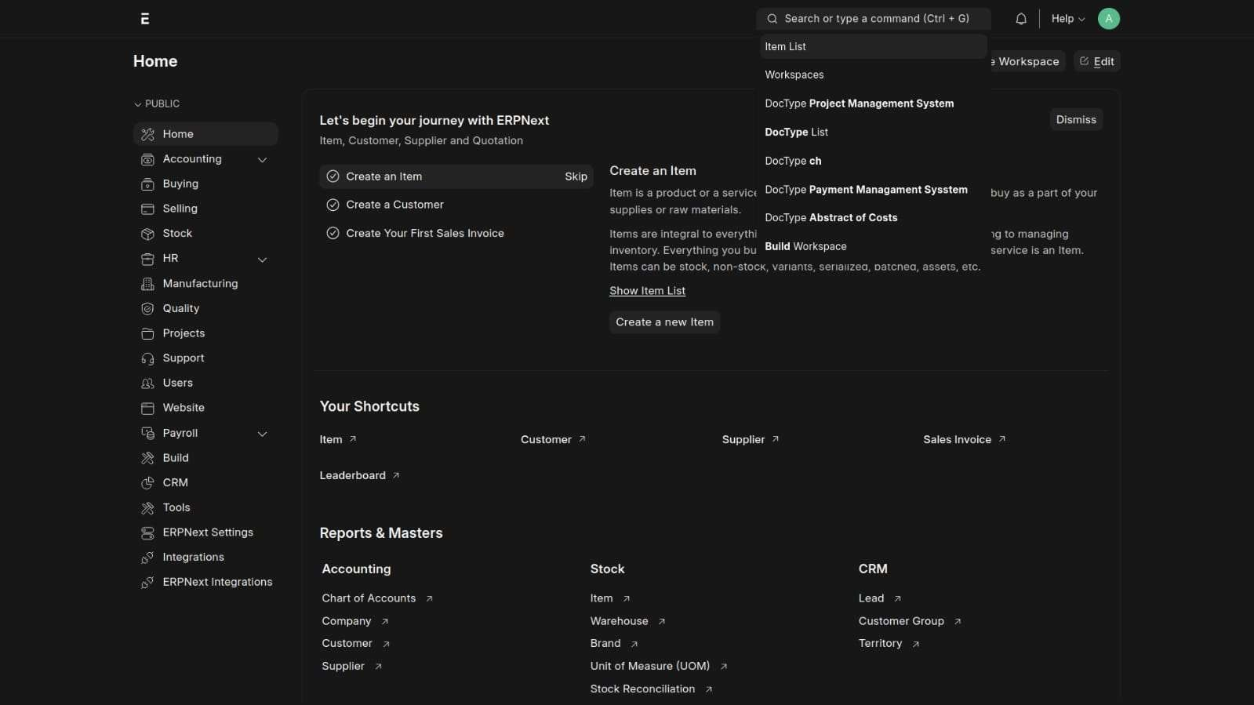

## Custom Doctype-(Payment Management System)

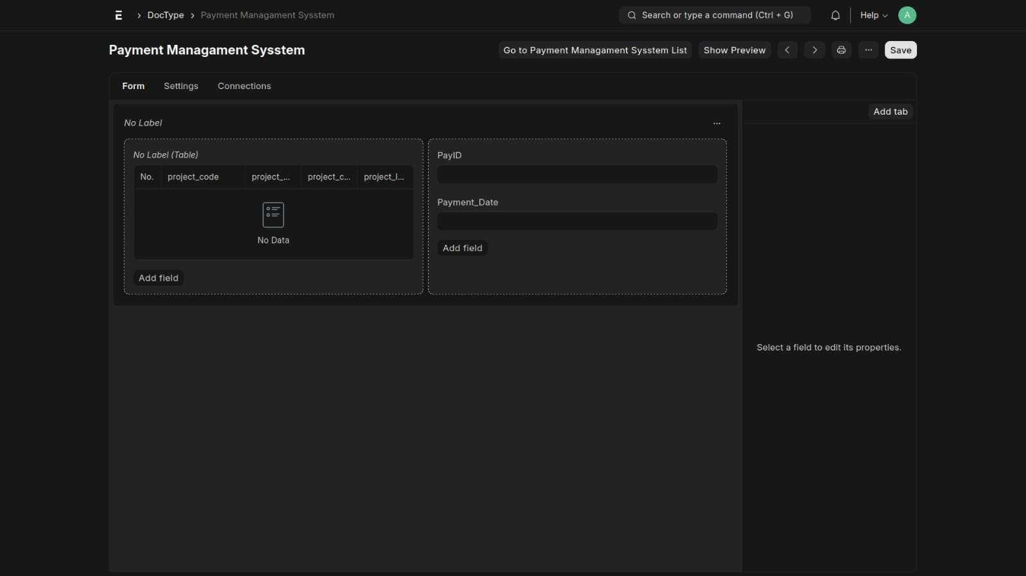

**Custom Doctype – (Abstract of Costs)**

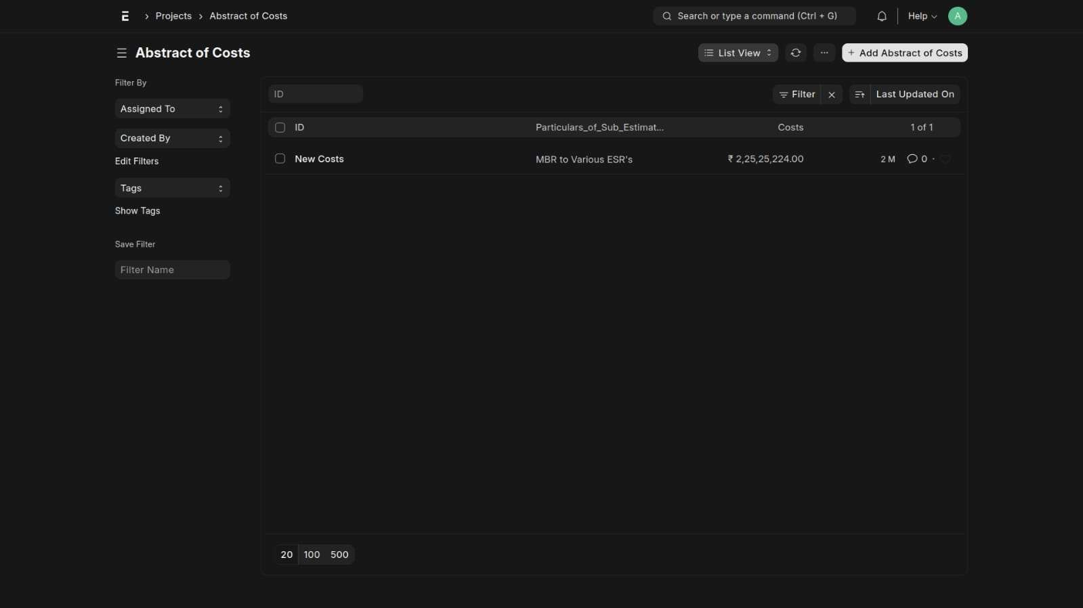

## Workflow Builder - ERPNext

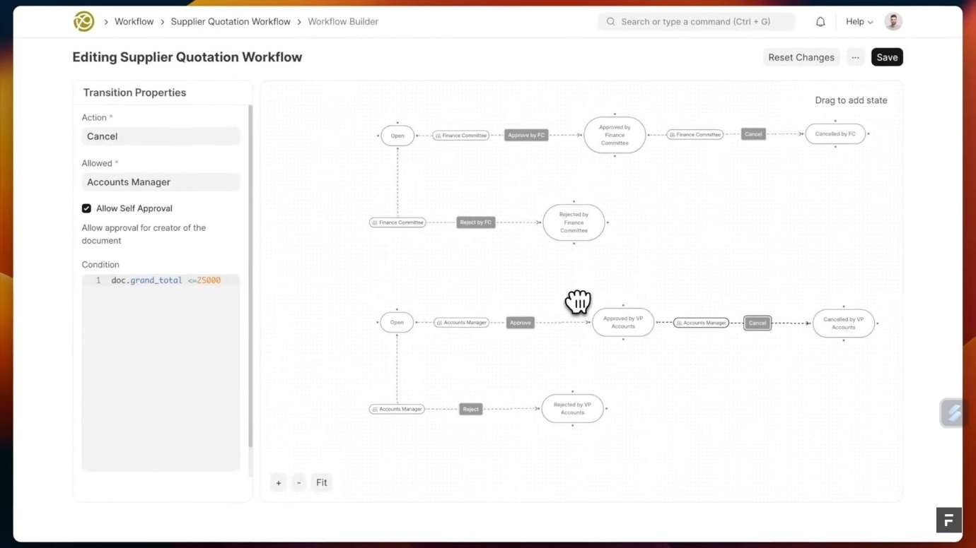

**REFERENCES**

* 1. Rohit Kenge (October 2020) A Research Study on the ERP System Implementation and Current Trends in ERP.
  2. https://archive.nptel.ac.in/courses/110/106/110106045/
  3. https://erpnext.com/
  4. https://frappe.io/